eQSL Synchronization

Geoff Anderson G3NPA

1.0 DOWNLOADING FROM eQSL

Downloading from eQSL is not easy or straightforward, but the facility DOES exist whereby one can download an ADI or TXT file containing received eQSL information. This can be used to synchronize your Logger32 log file.

There are two methods by which you can obtain the information:

  - Go to http://www.eqsl.cc/qslcard/DownloadInbox.cfm?username=callsign&password=password. Replace both the username and password with your callsign and actual eQSL password in the URL above; or,
  - Go to http://www.eqsl.cc/qslcard/DownloadInbox.cfm if you're already logged on to eQSL. If you take this route and you are NOT logged in, then eQSL will take you to the login page.

Go to https://www.eqsl.cc/QSLCard/DownloadADIF.cfm to download files from eQSL.

Either method will take you to this page:

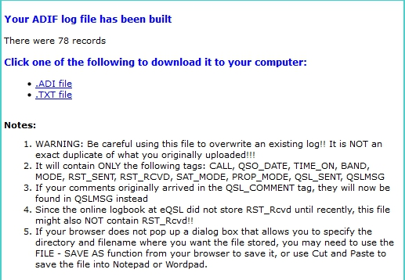

new ES_1

Click on the file type required.

At the time of writing this, the eQSL .ADI link in the resulting screen (above) was broken and so has not been tested. It is possible to use the .TXT link and copy/paste the results to a file. Give that file the extension .ADI

Example ADI file

If you want to download file for Synchronize eQSL then right click on ".ADI file". Click "Save Link"

The file will look like this:

ADIF 2 Export from eQSL.cc
Received eQSLs for G3NPA
for QSOs between 01-Jan-1970 and 09-Nov-2009
Generated on Sunday, February 8, 2004 at 13:23:07 Pacific Time
<PROGRAMID:20>eQSL.cc DownloadInBox
<ADIF_Ver:1>2
<EOH>
<CALL:5>G4TRA<QSO_DATE:8:D>19950121<TIME_ON:4>0000<BAND:3>80M<MODE:3>SSB<RST_SENT:2>58<RST_RCVD:0><QSL_SENT:1>Y<QSL_SENT_VIA:1>E<EOR>
<CALL:5>LX1HD<QSO_DATE:8:D>19950121<TIME_ON:4>2200<BAND:3>80m<MODE:3>SSB<RST_SENT:2>59<RST_RCVD:0><QSL_SENT:1>Y<QSL_SENT_VIA:1>E<EOR>

ADIF 3 Export from eQSL.cc
For JA1NLX
Generated on Thursday, July 20, 2017 at 22:35:42 PM UTC
<PROGRAMID:20>eQSL.cc DownloadADIF
<ADIF_Ver:5>3.0.4
<EOH>
<CALL:4>NX5M<QSO_DATE:8:D>19981212<TIME_ON:4>0025<BAND:3>10m<MODE:2>CW<RST_SENT:3>599<QSL_SENT:1>Y<QSL_SENT_VIA:1>E<QSLMSG:7>Thanks!<EOR>
<CALL:5>F6IRG<QSO_DATE:8:D>19991107<TIME_ON:4>0841<BAND:3>10m<MODE:3>PSK<SUBMODE:5>PSK31<RST_SENT:3>599<QSL_SENT:1>Y<QSL_SENT_VIA:1>E<QSLMSG:7>Thanks!<EOR>

2.0 SYNCHRONIZING LOGGER32

In Logger32 Main menu select the File| Synchronize to eQSL menu items and select the required file.

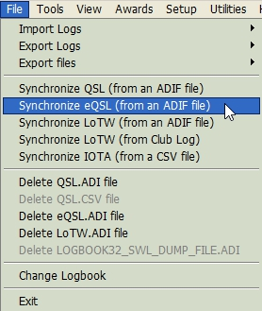

new ES_2

When the file has been loaded,the eQSL Synch dialog box.will be displayed. Select the <Start> button and you're off. All eQSL matches will be changed from a blank in the eQSL_RCVD column of the logbook to a Y.

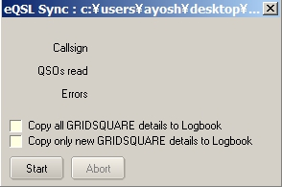

new ES_3

A valid eQSL ADIF file must have <PROGRAMID:20> field in the header (or it will be rejected). A search +/- 10 minutes of the QSO TIME_ON is done. If a QSO with the same callsign, same band, and same mode is found, and the eQSL_SENT field is Y, then it is assumed this is the correct QSO and the eQSL_RCVD field is set to Y.

As a reminder (as with the LoTW_SENT and LoTW_RCVD fields), the eQSL_SENT and eQSL_RCVD fields used in Logger32 are non-standard ADIF fields and probably will not be recognized by other software.

Notes:

QSL don't seem to do any validation on the GRIDSQUARE, IOTA and STATE, CNTY fields, but Logger32 checks these fields for validity during synchronization (and puts the invalid ones in the BAD.ADI file).

If Logger produces a BAD.ADI file, then check:

  - 1) The DATE/TIMES of the QSOs. It MUST be within +/- 10 minutes of what appears in your log - the fields in the format:

  - <QSO_DATE:8>20031023 <TIME_ON:6>004956

  - 2) IOTA field should be of the format xx-nnn. I suspect that the ADIF file received is without the dash, for example <IOTA:6>NA-033

  - 3) Grid information must be of the format XXnn or XXnnxx. For example <GRIDSQUARE:6>FM72nd or <GRIDSQUARE:4>FM72

eQSL sync looks -/+ 10 minutes for a QSO that matches (Call, Band and Mode). eQSL does not do an exact match check, it starts - 10 minutes and looks thru the log for 20 minutes for a match.

